Gas Leakage Monitoring and AlertingSystem

**DataFlowDiagram**

|  |  |
| --- | --- |
| Date | 13 October2022 |
| TeamID | PNT2022TMID14764 |
| ProjectName | Gas leakage monitoring alerting system for industries |
| TeamLead | Jaishiddharth Essaki |
| TeamMembers | Rishekesh.B  Lakshmikanth .T  Jayant Shankar |

DataFlowDiagramforGasLeakageMonitoringandAlertingSystemfor Industries:

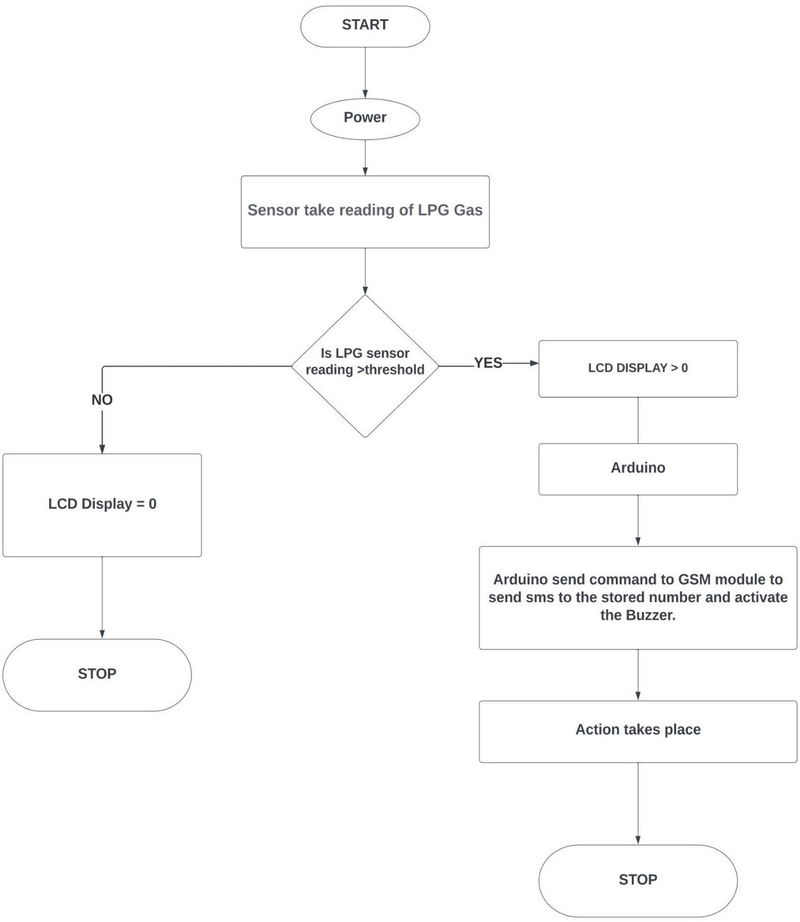

Stepsindataflow diagram:

1. PowerissuppliedtotheArduino
2. Sensor which is connected to the Arduino takes the reading of the LPG gas fromthegas cylinder
3. If the reading of the sensor is greater than the threshold value, the LCD DISPLAYis assignedto thevaluegreaterthanzero.
4. If the LCD DISPLAY is greater than zero, Arduino send the command to GSMmoduleto sendSMSto thestorednumberandactivatetheBuzzer
5. Sothatactionwilltakes placeandstop.
6. Ifthereadingofthesensorislessthanthresholdvalue,LCDDISPLAYisequaltozeroandthen stop.